## 

## 

## EE 242-02

## Electrical Engineering Department

## Lab #2

## Power Factor Correction

## Report Delivered on: 01-31-25

## Lab Partners: Allen Dinh, David Rock, Alan Odnoblyudov

## Group 1

**Introduction**

The objective of this lab was to study power factor correction in a circuit consisting of a 4.96 mH inductor, a 30.30 Ω resistor, and a 1.27 Ω resistor connected in series. A 2.64 µF capacitor was used as a corrective element to achieve a unity power factor with respect to the source.

**Equipment List**

1 5mH Inductor

2 Resistor Decade Box (1)

2 Capacitor Decade Box (1F range with steps of 0.1 and 0.01F)

1 Keysight EDU33121A Function Generator

1 Keysight EDU34450A Digital Multimeter

1 Keysight DSOX1202G Digital Storage Oscilloscope

2 Bags, short leads

3 BNC-double banana

1 5 mH high-Q inductor (obtain from checkout counter)

2 Banana-Banana leads

**Procedure**

**Section 1: Pre-Power Factor Correction**

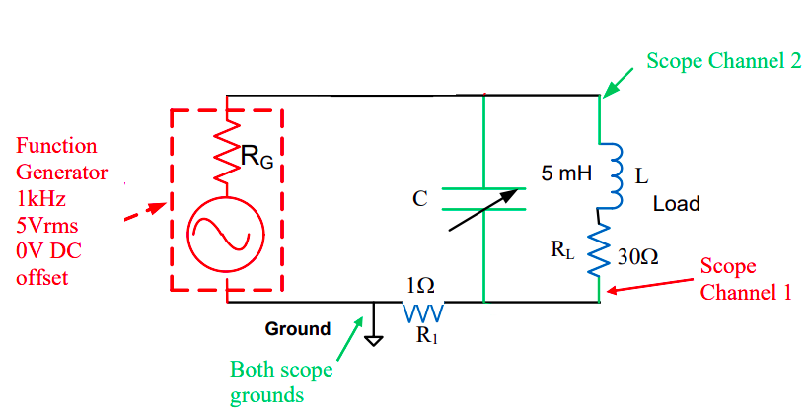

Figure 1.1: AC Network with Non-Unity Power Factor

1.1 Using Keysight DSOX1202G Digital Storage Oscilloscope measure the Angle between the Voltage Across R1 and the Negative of the Load Voltage without the Capacitor.

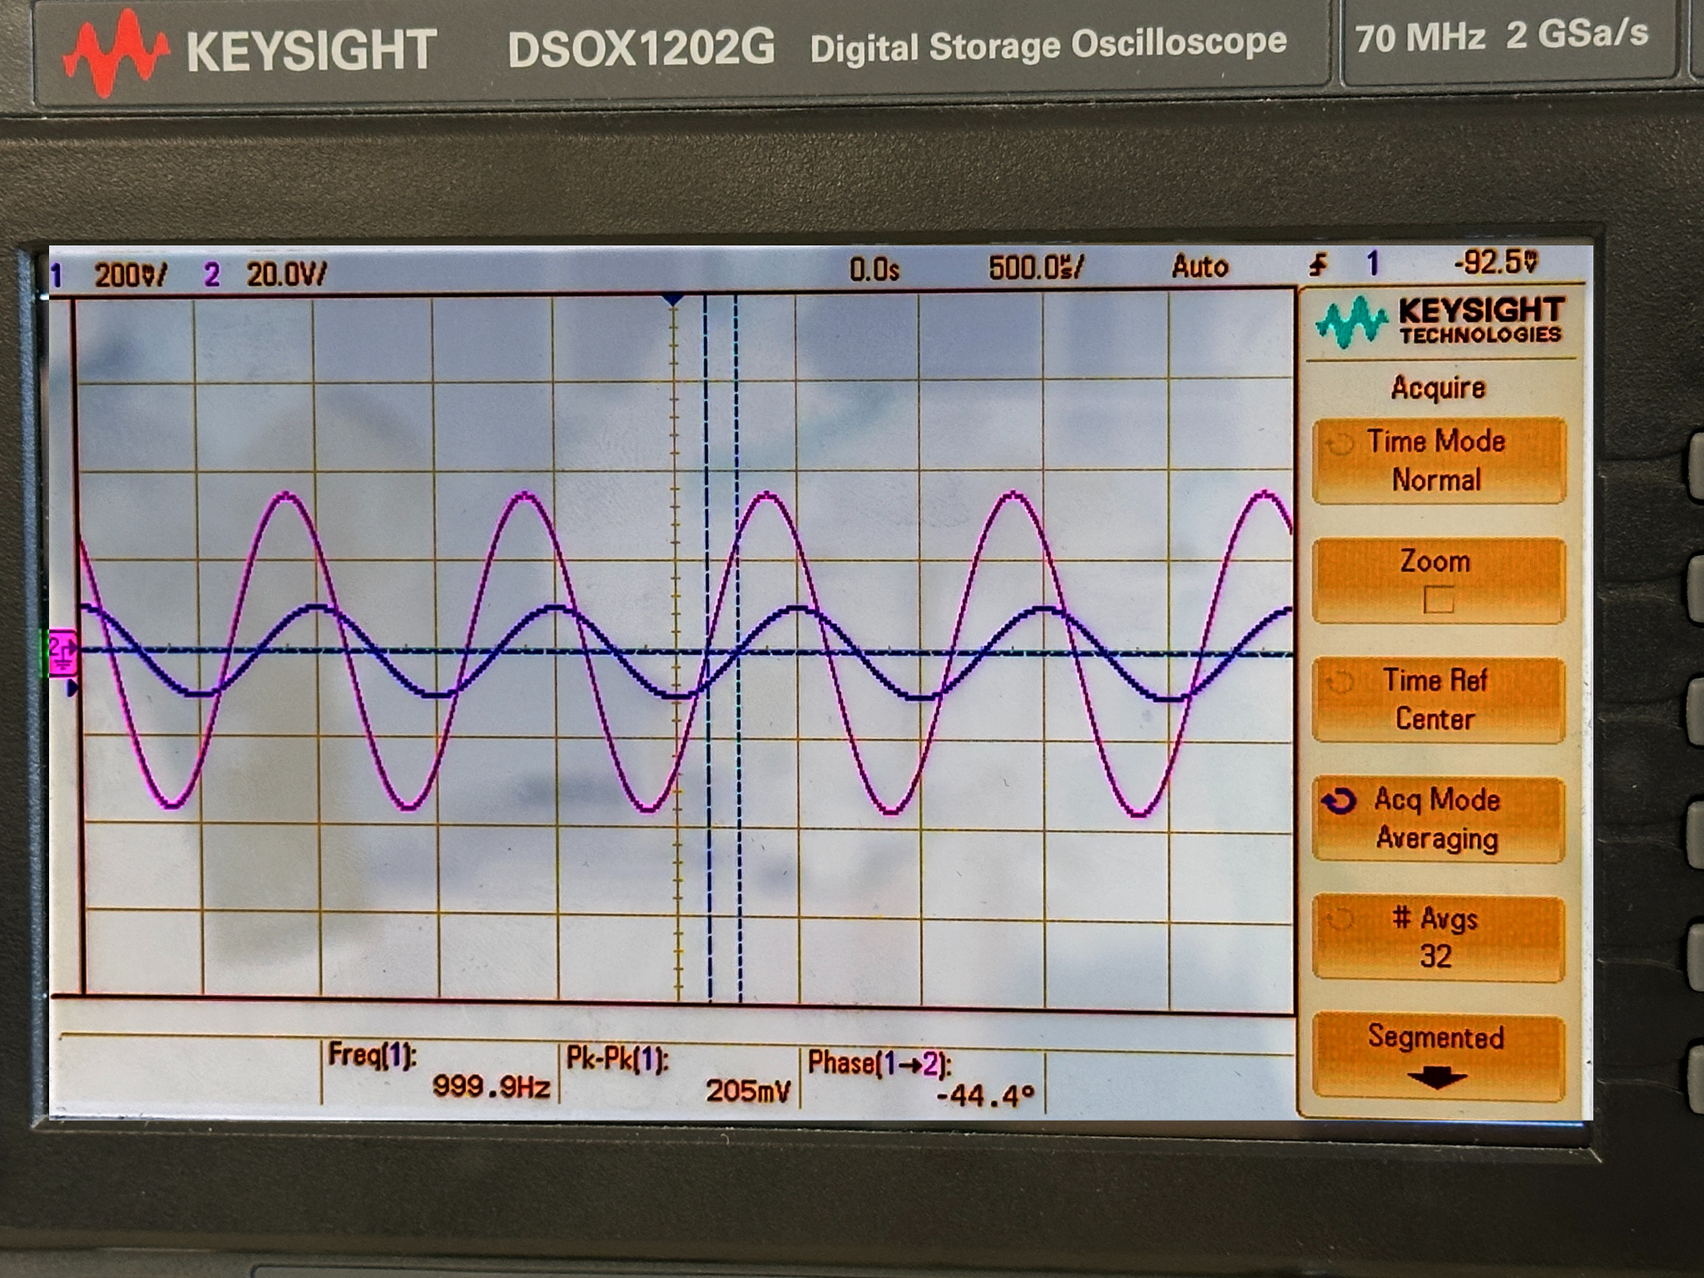

Figure 1.2: The sinusoidal waveforms of VR1 and -Vload without the capacitor are shown with a phase difference of -44.4o.

1.2 Determine Load Power Factor

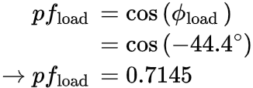

1.3 Determine the Load’s P and Q

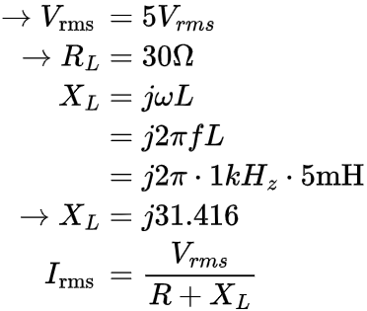





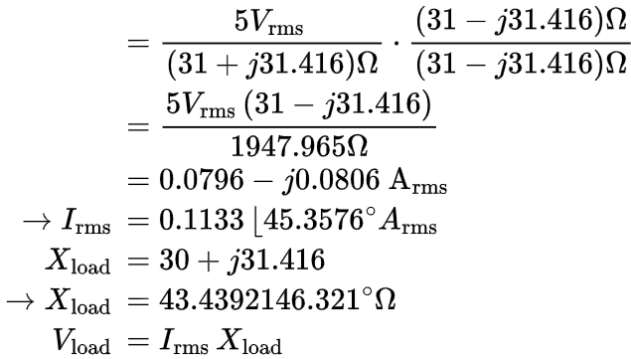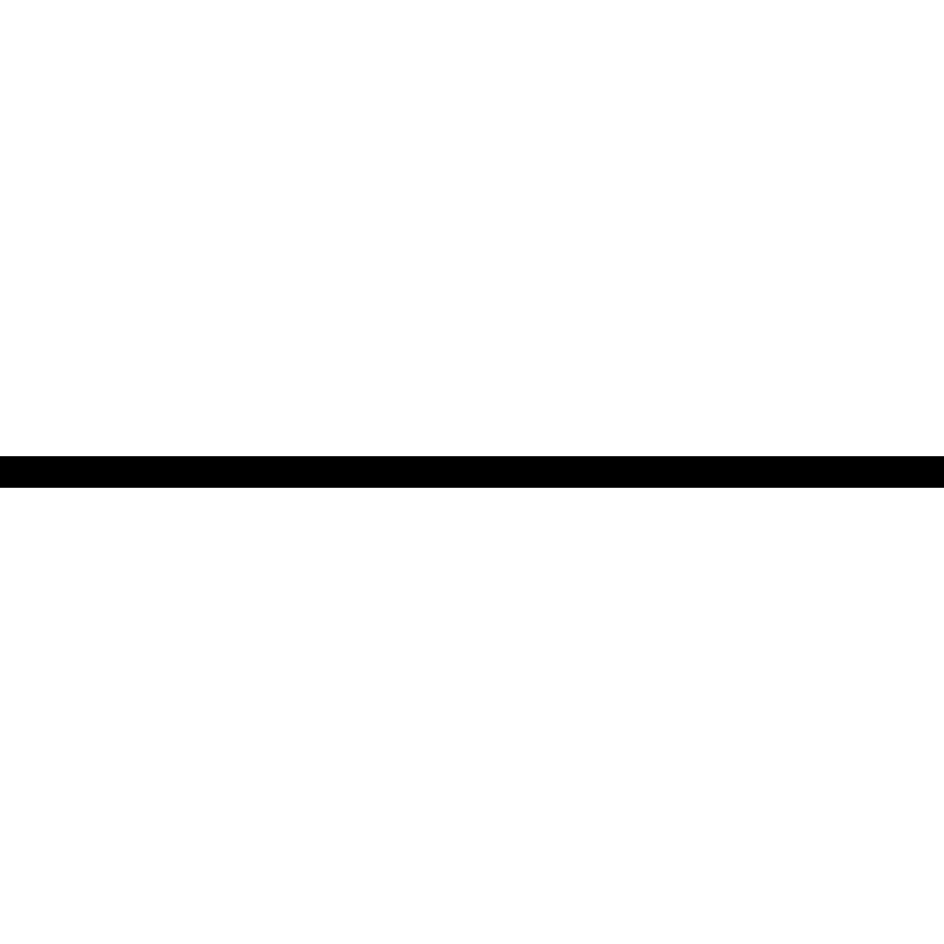

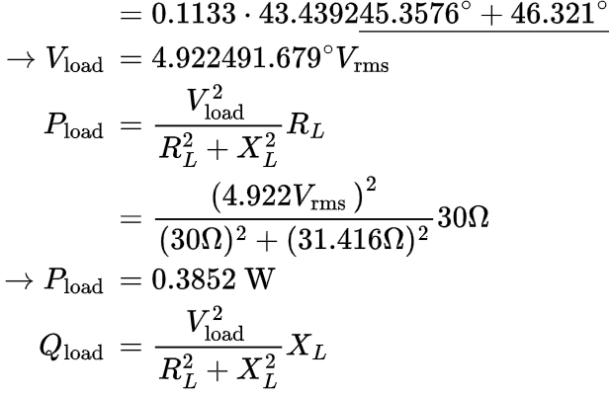

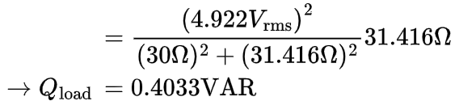

1.4 Measure Voltage Across R1 before Connecting the Capacitor

The measured Voltage using Keysight DSOX1202G Digital Storage Oscilloscope cursor was 0.192 Vrms.

1.5 Determine Power Consumed by R1

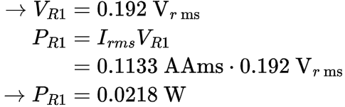

1.6 For the C=0 Case, Determine the Load Phase Angle θL Between Load Voltage and Circuit Current from the Lissajous Pattern

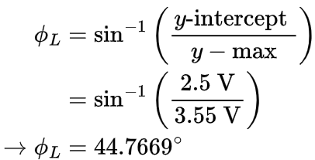

Note: all measurements were taken using hand-placed oscilloscope cursors. Y-intercept and Y-max were retrieved from Figures 1.3 and 1.4 on the next page.

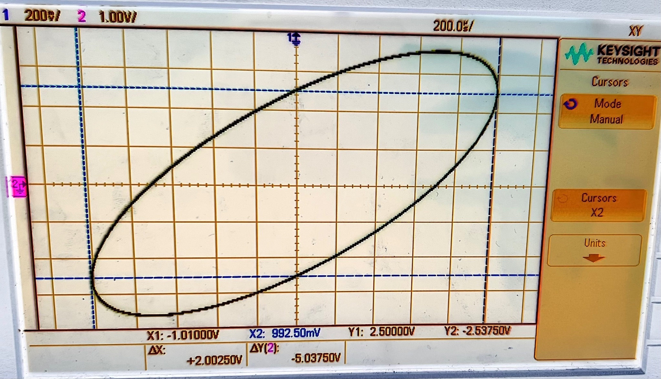

Figure 1.3: This Lissajous pattern of VR1 (Y-axis) and Vload (X-axis) Intercepts the Y-axis at (0, 2.5V) and (0,-2.537V)

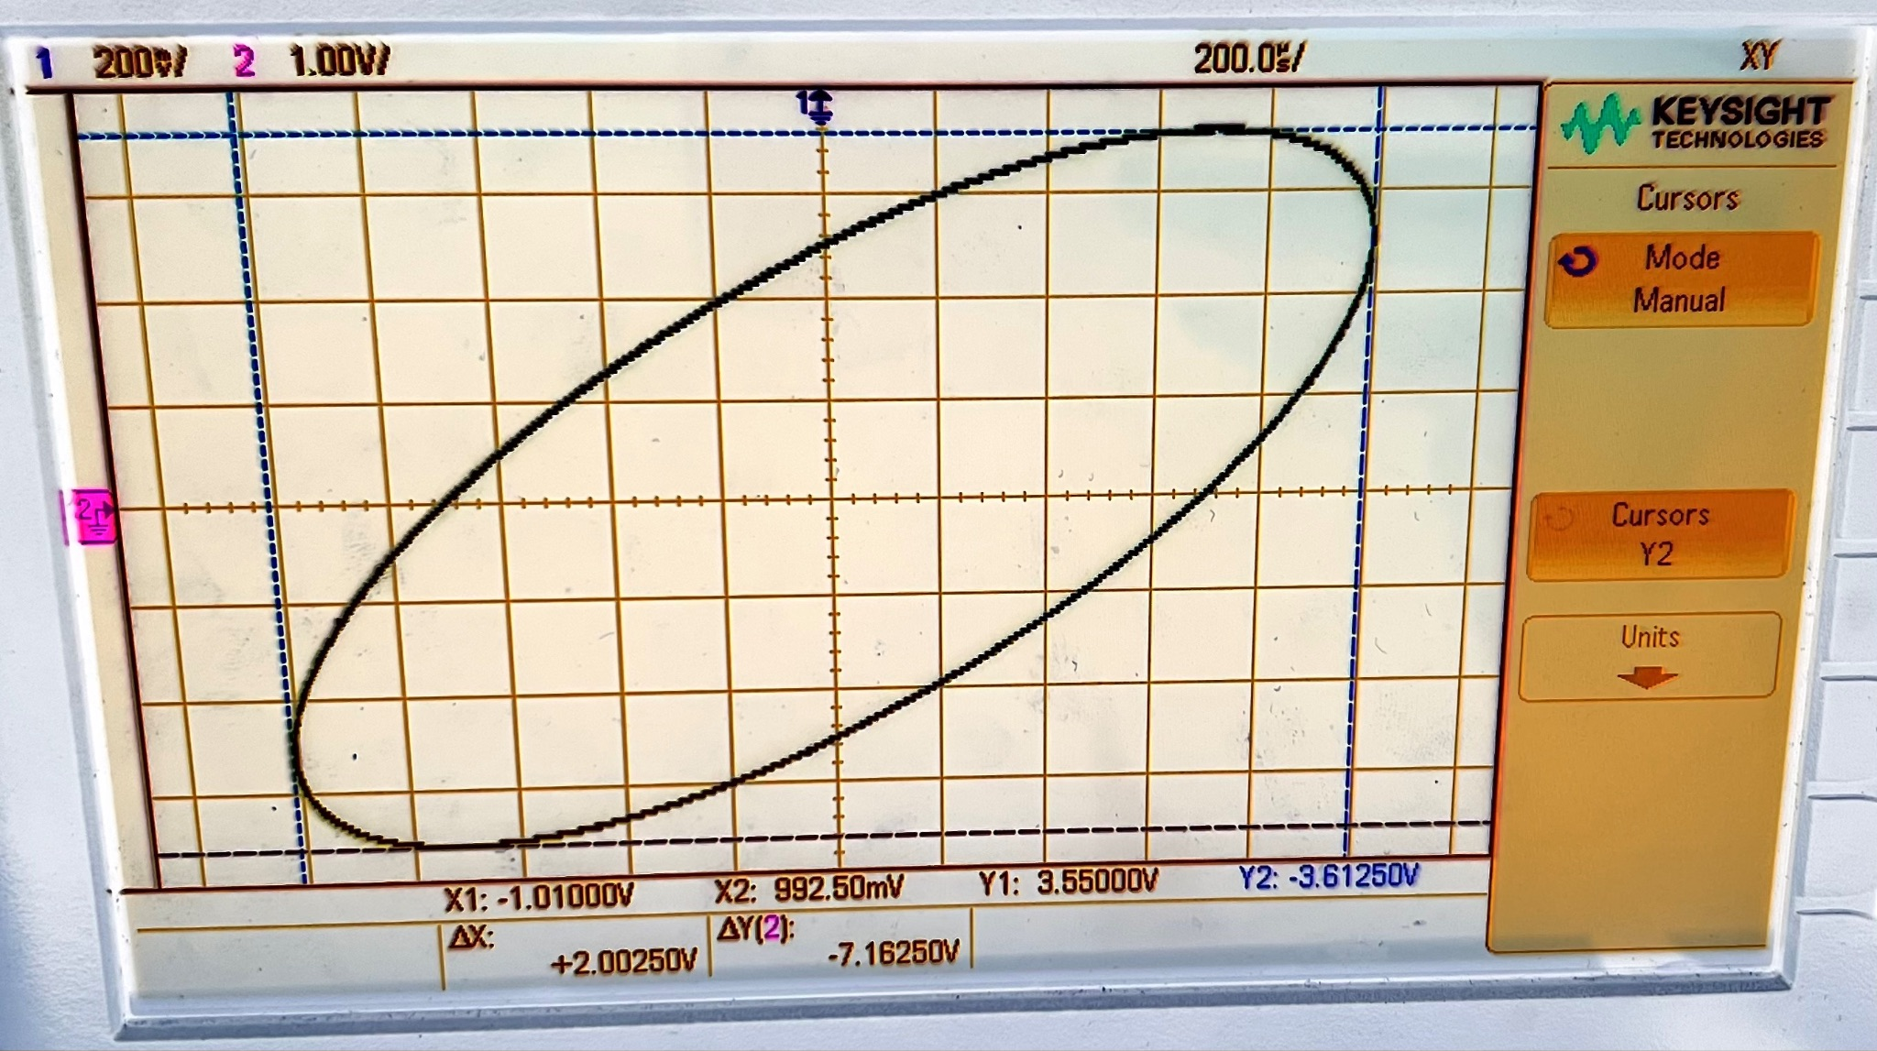

Figure 1.4: The Lissajous pattern of VR1 (Y-axis) and Vload (X-axis) displays the maximum amplitudes, with VR1 ranging from -1.01 V to 0.9925 V and Vload ranging from -3.6125 V to 3.55 V.

1.7 Compare to the Phase Angle Measured by the Oscilloscope and Justify Discrepancies

The measured angles show a discrepancy of 0.4° (0.09%), likely due to imprecise cursor placement or the Keysight DSOX1202G oscilloscope’s auto-calculation incorrectly placing the cursors.

**Section 2: Post-Power Factor Correction**



Figure 2.1: Power Factor Compensated AC Network

2.1 Beginning with the Expected C Value (From the Prelab), Vary C by 0.1uF to Produce a Voltage Across R1 (the current) In or Out of Phase (0° or 180°) with the Voltage Across the Load

The pre-lab yielded a theoretical capacitance value of 2.64 µF. Taking measurements during the lab, the capacitance value measured 2.59 µF. This produces a phase difference between VR1 and Vload of 0°.

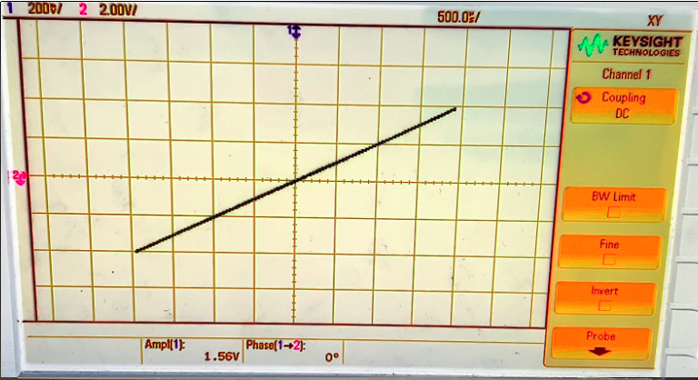

Figure 2.2: This Lissajous pattern of VR1 (Y-axis) and Vload (X-axis) Shows Their Phase Difference of 0o

2.2 Measure the Voltage Across R1 with Unity Power Factor

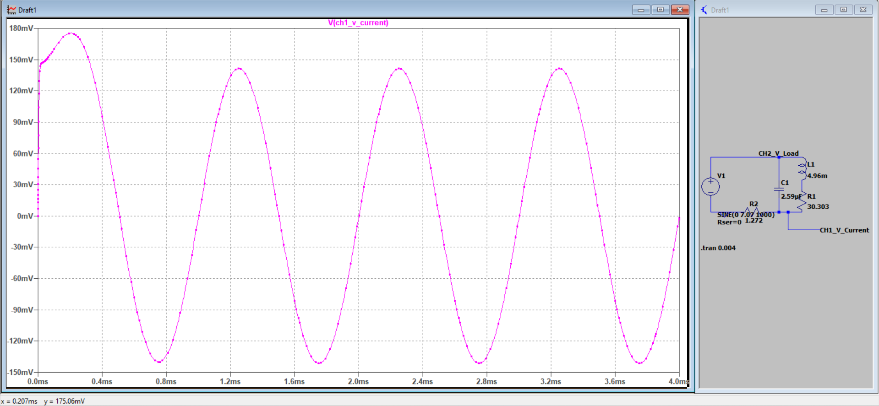

Figure 2.3: VR1 with Unity Power Factor, with a Peak at 175.06 mV

2.3 Determine the Power Consumed by R1

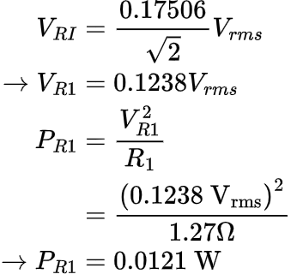

2.4 Compare this Power to the Power Before the Addition of the Capacitor and Comment on Differences

Before the capacitor was added, R1 consumed 0.0218 Watts. After adding the capacitor, R1 consumes a lower 0.0121 Watts. This decrease in power is expected because the capacitor affects the voltage across R1. As the capacitor charges, it diverts some of the current, reducing the voltage across R1. Since power is proportional to voltage, a lower voltage across R1 results in reduced power dissipation.

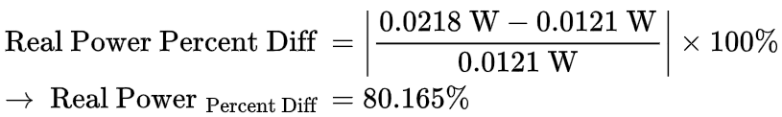

**Conclusion**

* An inductor produces positive reactive power, while a capacitor produces negative reactive power.
* Adding a properly rated capacitor (2.59 µF) fully cancels the reactive power (Q), leaving only a resistive load. This ensures that all power in the circuit is real power (P).
* Figure 2.2 showcases a straight diagonal line Lissajous Pattern which signifies a 0° phase difference between Vload and VR1.

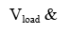



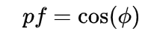

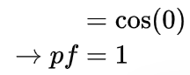

Power Factor Discrepancy:

* Calculations (Section 1.6, p.5) predict the load phase angle (ɸL ) between load voltage and circuit current to be ɸL = 44.7669°, whereas a perfect diagonal Lissajous pattern (signifying pf=1) corresponds to ɸL = 45°.
* This suggests that the measured power factor is approximately 1 but not exact unity.

Capacitance Comparison:

* Pre-lab calculated capacitance: 2.64 µF
* Measured capacitance during the experiment: 2.59 µF

